**Installation Guide**

Download the source code from GitHub repository

* + <https://github.com/sangam-iss/ISA-IPA-2019-10-30-IS01FT-SANGAM-CAREBOT.git>
  + (should not have space in the file-path, Tag-UI has been used)

**Python Flask Setup:**

1. Open folder ISA-IPA-2019-10-30-IS01FT-SANGAM-CAREBOT\system_code\fulfillment_with_rpa_system
2. Copy the given credentials.json file into the above folder
3. Create Conda Environment:
   1. Conda create -n “sangam-ipa” python=3.6 ipython
   2. Conda activate sangam-ipa
   3. Pip install -r requirements.txt
4. Run the flask app (python app.py)

**NGROK Setup:**

1. NGROK is used to connect the local hosted flask app to the Dialogflow .
2. Download NGROK for windows:
   * <https://ngrok.com/download>
3. Unzip the downloaded NGROK and run the following command prompt:
   * Ngrok.exe http 5000
4. Copy the link shown below. This link needs to be used in dialogFlow later.
   * 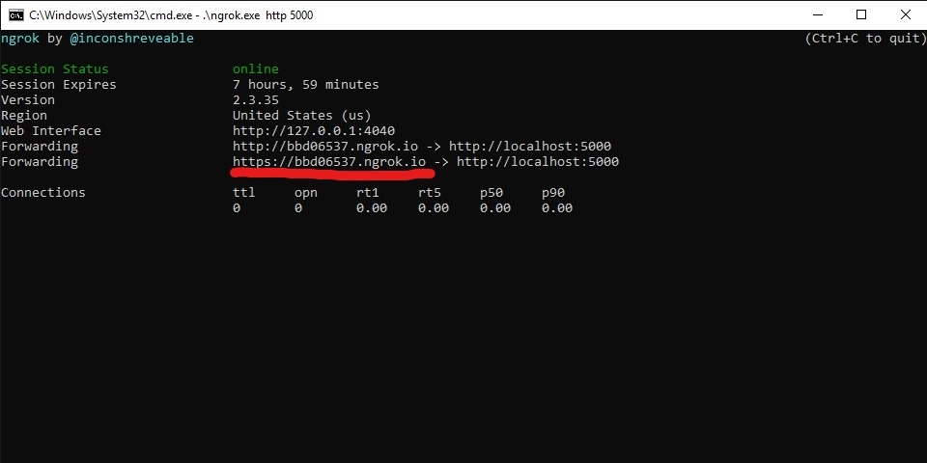

**DialogFlow Setup:**

1. Go to URL <https://dialogflow.cloud.google.com/#/login>

1. Login using google credentials
2. Follow the given video and create a DialogFlow agent with carebot.zip downloaded from github
   * <https://www.youtube.com/watch?v=ii2woEMJHQQ&feature=youtu.be>
3. Delete the “Default Welcome Intent" in Intents
4. Go to Fulfilment Tab in DialogFlow and enable fulfilment
5. Paste the copied NGROK link in the URL of fulfilment as follows:
6. NGORK_URL/v1/carebot

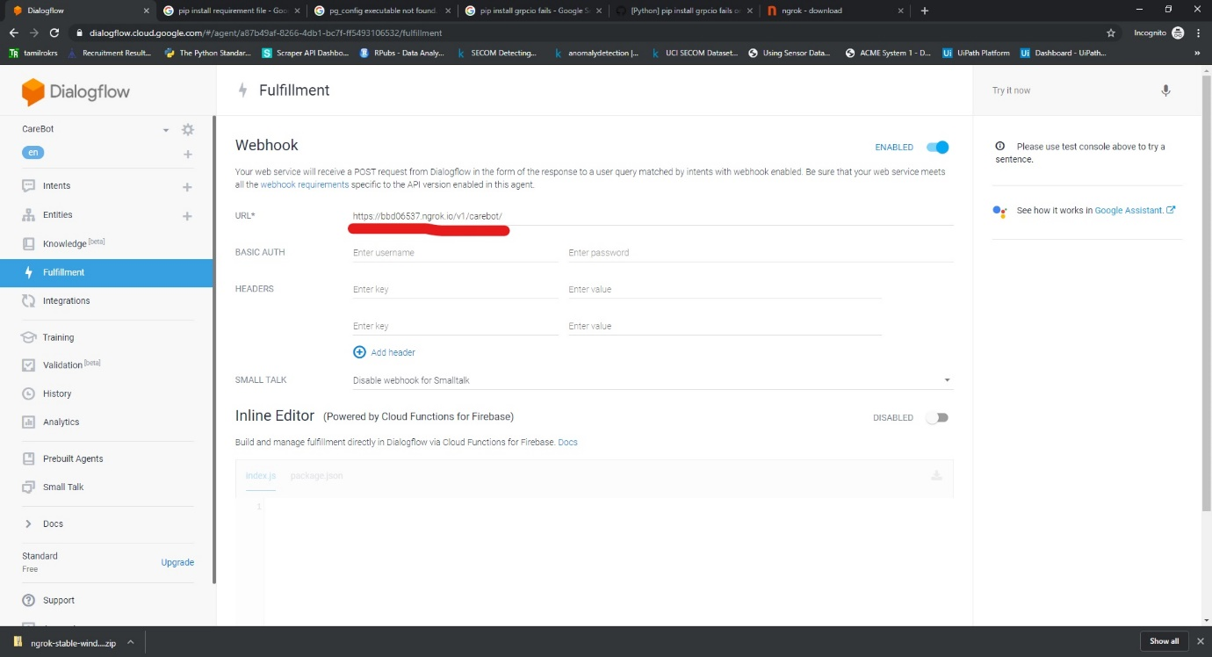

1. **Account Linking and Voice Invocation:**

Follow the below video for google account linking and voice invocation

* + <https://www.youtube.com/watch?v=3inKuZ2M6Pw&feature=youtu.be>

1. **Email Permissions**: App needs Email permission so that we can identify and manage appointment based on email. System asks for email for every fresh user. Follow the below link to give permission to access email.
   * <https://www.youtube.com/watch?v=OeaqJw-Y_QY&feature=youtu.be>
2. **Manage the users’ calendar events**: For the system to manage the user’s calendar, the user should ask “Manage my calendar” so that the system will prompt the user to authorize this task and get authorization token to create modify and delete events from the users’ calendar in future tasks. This is a one-time process.

Follow the below video to initiate the system and give necessary permissions to the chatbot

* + <https://www.youtube.com/watch?v=Hz_u2tYd8Ak&feature=youtu.be>